MATH 396 - Assignment

Trevor Dallow

April 17, 2017

Question 1

Draw the bifurcation diagram for fa(x) = x3 + ax. Make sure you indicate which segments correspond to stable and unstable periodic orbits. (Note: the bifurcation diagram contains all periodic points, not just the fixed points.)

f' = 3x2 + a

Solve: f' = 1 => 3x2 + a = 1 f = x => x3 + ax

a = 1, x = 0

When a >= 1, there is one fixed point, when a < 1, there are 3 fixed points, there are no other periodic points. As lima -> 1-, two fixed points merge towards a third fixed point at x = 0 at the ciritical value (bifurcation point) a = 1. Continuing to increase a from 1 yields no change in the position of the fixed point.

When a = 1, there is one fixed point, of neither stability. When a > 1, there is one unstable, fixed point. When a < 1 there is one stable fixed point (at x = 0) and two unstable fixed points.

a = -1:1  
x = seq(from = -2, to = 2, by = .01)  
  
plot(x, x, type = "l", main = "x^3+ax for various a and degrees", ylab = "f")  
grid(nx = 2, ny = 2)  
  
f = function(a, x) {  
 x^3+a*x  
}  
  
for (i in 1:length(a)) {  
 lines(x, f(a[i], x), col = i + 1, lty = 1)  
}  
  
for (i in 1:length(a)) {  
 lines(x, f(a[i], f(a[i], x)), col = i + 1, lty = 2)  
}  
  
legend("topleft", c(paste0("a(", a, ") n(1)"), paste0("a(", a, ") n(2)")), col = 2:(length(a) + 1), pch = c("_", "_", "_", "-", "-", "-"), title = "f^n_a")

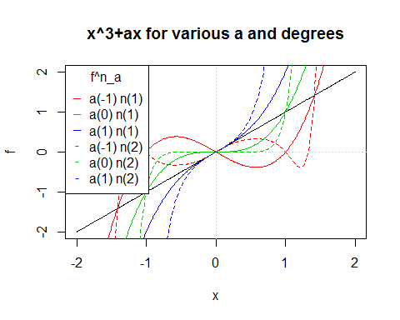

**Partial Bifurcation Diagram**  
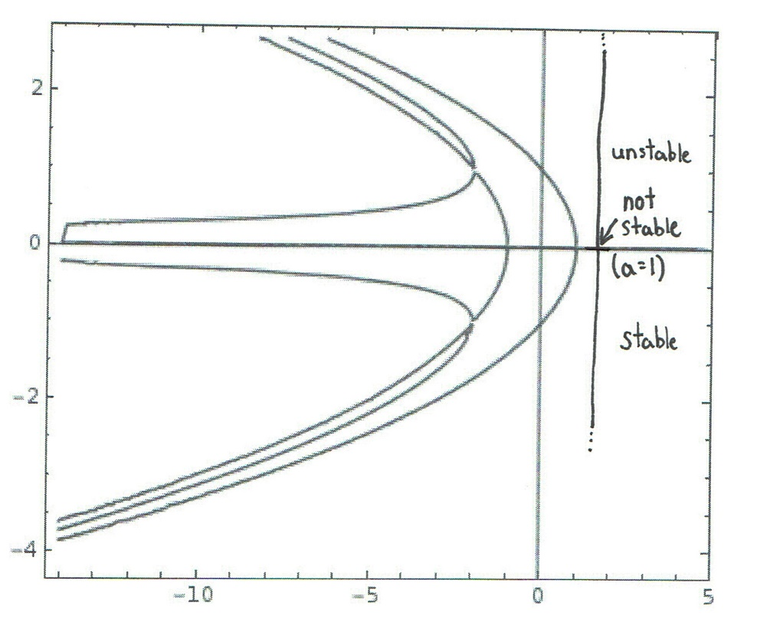

Question 2

Use the octal decomposition given in the notes (Ch 1) to classify the orbit topology near a fixed point. Use our convention of Li (Rj) indicating the ith point in the orbit on the left (respectively right) of the fixed point, and a < b (a > b) to indicate that the point a is closer to the fixed point (p) than b (respectively, a is further from the fixed point than b). You will not be able to unambiguously classify all (16) cases, but explain why not.

x = -1:1  
plot(x, x, type ="l", xaxt = "n", yaxt = "n", xlab = "", ylab = "", main = "Octant Decomposition")  
lines(x, -x)  
grid(nx = 2, ny = 2)

**Octant Decomposition**

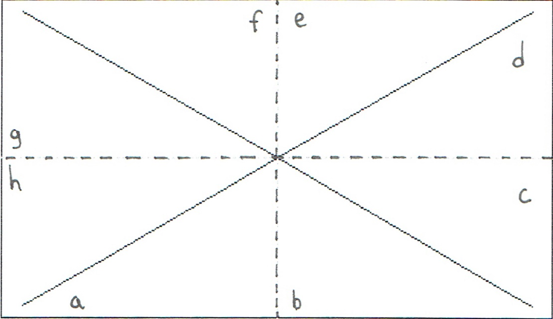

Let us first examine a few of the unambiguous cases.

I: Region {a, d}   
x_0 lies in a: L1 < L2 < L3 < ...   
 d: R1 > R2 > R3 > ... -> p   
Orbit staircases out from p if x_0 lies in a into p if x_0 lies in d.  
 The orbit about a fixed point p in this region is not stable.

II: Region {a, e}   
x_0 lies in a: L1 < L2 < L3 < ...   
 e: R1 < R2 < R3 < ...  
Orbit staircases out from p.   
The orbit about a fixed point p in this region is unstable.

III: Region {h, d}   
x_0 lies in h: L1 > L2 > L3 > ... -> p   
 d: R1 > R2 > R3 > ... -> p  
Orbit staircases into p.   
The orbit about a fixed point p in this region is stable.

IV: Region {h, e}   
x_0 lies in a: L1 > L2 > L3 > ... -> p  
 d: R1 < R2 < R3 < ...  
Orbit staircases into p if x_0 lies in h out from p if x_0 lies in e.   
The orbit about a fixed point p in this region is not stable.

par(mfrow = c(2, 2), mar = rep(.2, 4))  
for (i in 1:4) {  
 plot(x, x, type ="l", xaxt = "n", yaxt = "n", xlab = "", ylab = "")  
 lines(x, -x)  
 grid(nx = 2, ny = 2)  
}

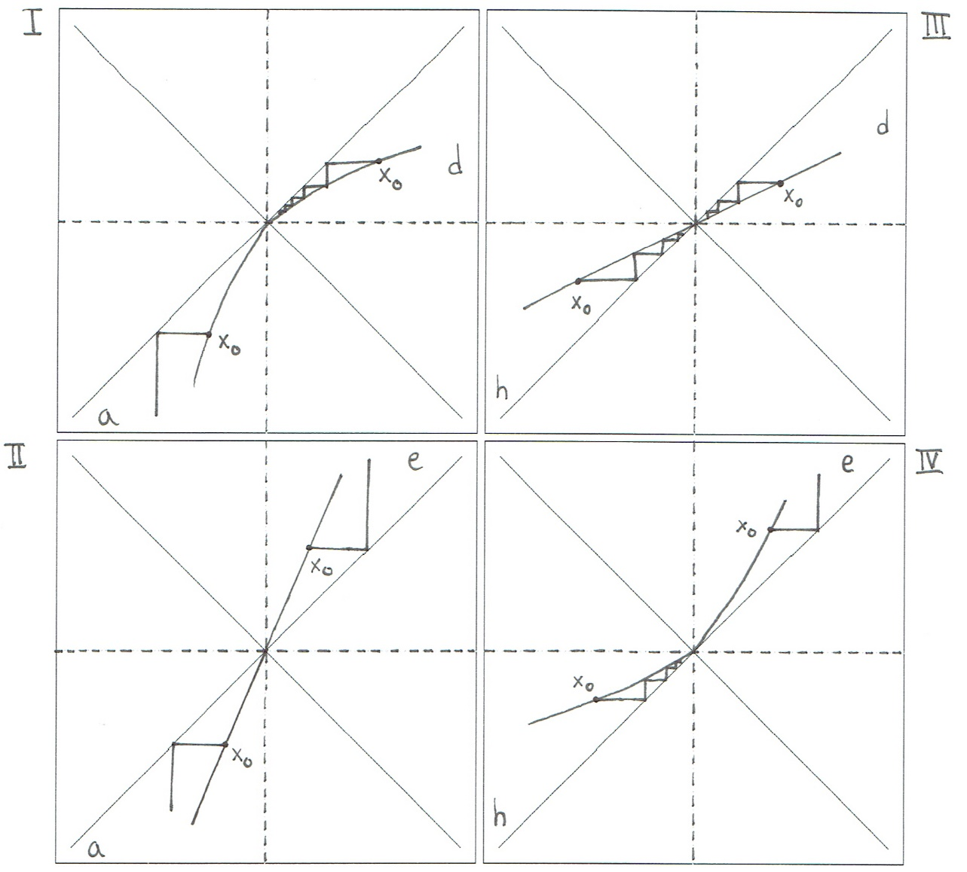

For regions {f, c} and {g, b} cannot be classified unambiguously, orbital behaviour varies for an arbitrary function even if the function lies within the same region. Further decomposition is needed, new sections defined by the lines -x/2 and -2x help classify cases within the two regions listed.

plot(x, x, type ="l", xaxt = "n", yaxt = "n", xlab = "", ylab = "", main = "Further Decomposition")  
lines(x, -x)  
lines(x, -2*x)  
lines(x, -x/2)  
grid(nx = 2, ny = 2)

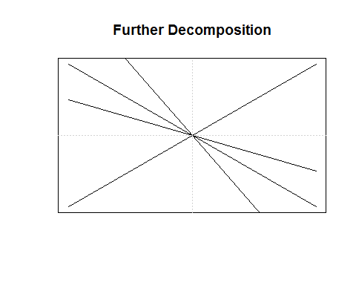

I: Region {g, b} Case 1 L1 = R1 = L1 = ...   
Orbit spirals around p, neither approaching nor moving away from the fixed point.   
The orbit about a fixed point p in this region is not stable.

II: Region {g, b} Case 2 L1 > R1 > L2 > ... -> p   
Orbit spirals into p.  
The orbit about a fixed point p in this region is stable.

III: Region {f, c} Case 1 L1 = R1 = L1 = ...   
Orbit spirals around p, neither approaching nor moving away from the fixed point.  
The orbit about a fixed point p in this region is not stable.

IV: Region {f, c} Case 2 L1 < R1 < L2 < ...   
Orbit spirals out from p.   
The orbit about a fixed point p in this region is unstable.

par(mfrow = c(2, 2), mar = rep(1.5, 4))  
  
for (i in 1:2) {  
 plot(c(-1, 1), c(-1, 1), type ="l", xaxt = "n", yaxt = "n", xlab = "", ylab = "", main = "Further Decomposition {g, b}")  
 lines(c(-1, 1), -c(-1, 1))  
 lines(c(0, 1), -2*c(0, 1))  
 lines(c(-1, 0), -c(-1, 0)/2)  
 grid(nx = 2, ny = 2)  
  
 plot(c(-1, 1), c(-1, 1), type ="l", xaxt = "n", yaxt = "n", xlab = "", ylab = "", main = "Further Decomposition {f, c}")  
 lines(c(-1, 1), -c(-1, 1))  
 lines(c(-1, 0), -2*c(-1, 0))  
 lines(c(0, 1), -c(0, 1)/2)  
 grid(nx = 2, ny = 2)  
}

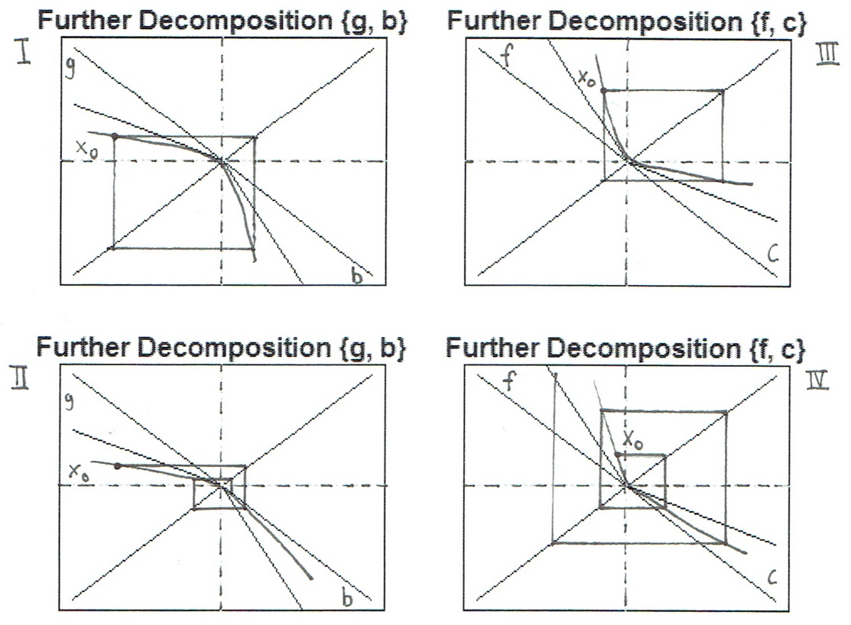

Question 3

Refer to Chapter 2 notes (pages 10,11) to prove that if a is a bifurcation point of fa(x), then dxfa(x) = 1 at a = ā, x = pā (here we write the fixed point as p(a) to exhibit its dependence on a).

Let pā be a fixed point of fa when a = ā and assume fa(x) is differentiable in both x and a at (ā, pā). Given that ā is a bifurcation point of fa(x), suppose dxfa(x) ≠ 1 at a = ā, x = pā. We know that, for ā to be a bifurcation point of fa(x), the following two conditions must hold:

dxfa =1,   
 fa = x

So it must be the case that

dx fa = 1 and fa = x at a = ā, x = pā

But if ā is a bifurction point, it must be the case that

dxfa = 1 at a = ā, x = pā

and so we have a contradiction.

Thus dxfa = 1 at a = ā, x = pā when ā is a bifurcation point.

Also, at a period doubling bifurcation point ā of fa, that necessarily dxfa(x) = -1 at a = ā, x = pā. And note that this is what we observe graphically (see the notes page 4 Lecture 2 and page 28 of the presentation that is posted in the 'Lectures' folder on Canvas (at the top!).

Now, suppose ā is a period doubling bifurcation point of fa. We wish to show that dxfa = -1 at a = ā, x = pā. If ā is a period doubling bifurcation point of fa, it must be the case that:

dxfa2 = 1,   
 fa2 = x

Since the period 1 point remains throughout bifurcation,

dxfa ≠ 1

And so

dxfā2 = 1 => dxfa = ±1 (since dxfa2 = (dxfa)2 and 1 = (±1)2)

But since dxfak =/= (where k is some integer > 1), it must be the case that dxfa = -1 at a = ā, x = pā. Thus dxfa = -1 at a period doubling bifurcation point a = ā, x = pā.

Question 5 Shadow Lines

(a) Why doesn't the diagram have points from the bottom (x = 0) to the top (x = 1)? That is, although fa(x) is defined on the entire interval [0, 1], we only see points in the final state diagram in a smaller subinterval.

The diagram is not defined over the entirety of its interval [0, 1] because the maximal value for the logistic equation is a/4 for varying a [0, 4]. No points exist in the diagram for values > a/4. As well, no points exist below a lower boundary of f(va) where va = f(0.5) for the logistic equation.

1. Determine the curves where there is a higher density of points in the final state diagram and plot them.

Let va = fa(0.5) denote the upper bpoundary of the final state diagram of the logistic equation, as well as the highest peak in the density histogram. Further, let fa(va), fa2(va), fa3(va) the curves of the next highest peaks in the density histogram. The reason for the prominance of these points is that the peaks of the density histogram indicate the points that define the shadow lines.

a = seq(from = 0, to = 4, by = .001)  
x = .5  
n = 5  
f = a*x*(1-x)  
plot(a, f, type = 'n', xlim = c(3,4), ylim = c(0,1), main = "Shadow Lines of Logistic Equation")  
for (i in 1:n) {  
 lines(a, f, col = i)  
 f = a*f*(1-f)  
}  
legend("bottomleft", c("v", paste0("f^", 1:(n-1))), pch = "_", col = 1:n)

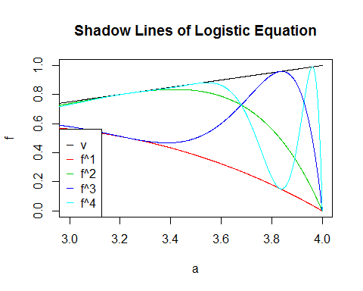

Question 8

A dynamical system depends on a parameter a. Initially, you observe a steady state (i.e., a period 1 orbit). As a increases you observe a period 2 oscillation appearing at a = a1 = 7. Then at a = a2 = 10 you observe that the period 2 orbits splits into a period 4 orbit. As a continues to increase a series of period-doublings occurs. Assuming Universality, at what a value would you expect to observe the onset of chaos? ('Assuming Universality' means assuming that the system will go through a series of period-doubling bifurcations as the parameter a changes, and that the distance (in a) between bifurcations is given by the Feigenbaum constant.)

Observed chaos can be expected to happen when a exceeds the Figenbaum constant a∞. Also we know that the rate at which bifurcations occur is the same for many dynamical systems, so assuming that this system behaves similarily to the logistic equation, we may use the rates at which the logistic equation bifurcates to help us determine the value that we expect to see observed chaos.

a = matrix(NA, nrow = 7)  
p = matrix(NA, nrow = 7)  
d = matrix(NA, nrow = 7)  
r = matrix(NA, nrow = 7)  
  
a[2] = 7  
a[3] = 10  
p[1] = 1  
d[3] = a[3] - a[2]  
r[3] = 4.7514  
r[4] = 4.6562  
r[5] = 4.6682  
r[6] = 4.6687  
r[7] = 4.6693  
for (i in 2:length(p)) {  
 p[i] = p[i - 1] * 2  
}  
  
for (i in 4:length(r)) {  
 d[i] = (1 / r[i]) * d[i - 1]  
 a[i] = d[i] + a[i - 1]  
}  
  
BifPointTab = cbind(a, p, d, r)  
colnames(BifPointTab) = c("Bifurcation Point", "Period", "Difference", "Ratio")  
BifPointTab

## Bifurcation Point Period Difference Ratio  
## [1,] NA 1 NA NA  
## [2,] 7.00000 2 NA NA  
## [3,] 10.00000 4 3.000000000 4.7514  
## [4,] 10.64430 8 0.644302221 4.6562  
## [5,] 10.78232 16 0.138019412 4.6682  
## [6,] 10.81188 32 0.029562707 4.6687  
## [7,] 10.81822 64 0.006331293 4.6693

print(paste0("Approx. value of a where chaos can be observed: ~", BifPointTab[7, 1]))

## [1] "Approx. value of a where chaos can be observed: ~10.8182156337291"

We need more ratios and further analysis to find a better approximation than a∞ ~10.8182, the true value would be slightly larger than this value.